**小巧机身，高效焊接**

焊接速度是传统氩弧焊、等离子焊的3-10倍 ；焊接热影响区域小，不会导致共建变形、发黑、背面有痕迹等问题、 且焊接深度大，熔化充分，焊接牢固。

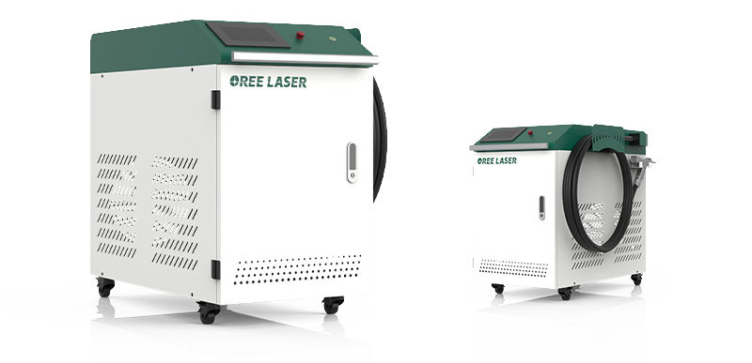

**双驱手持摆动激光焊接头**

6种焊接模式，多种焊接喷嘴，满足不同焊接需求；具备安全感应功能，接触金属后发出激光，移开自动锁光；螺旋抖动功能，焊缝宽度可调节，焊接能力显著提升。

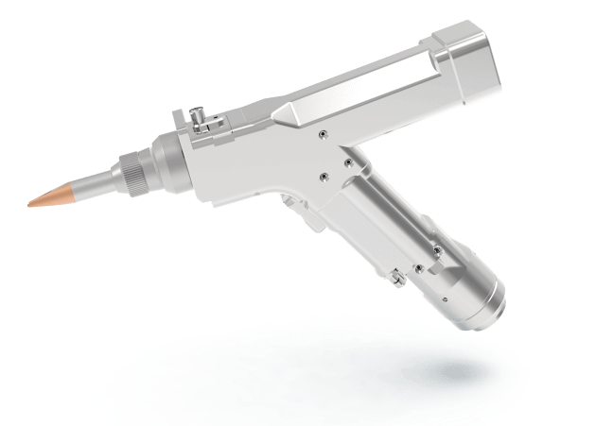

**简易操作面板**

显示屏操作界面简单醒目。配备单项按钮，无需编程示教，拿手即焊。

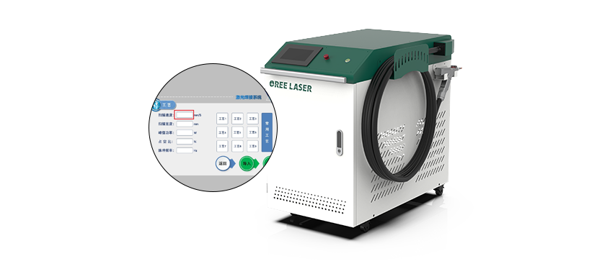

**水冷机**

双温双控，循环水路，可快速冷却焊接头内部管路腔体，同时对激光器进行降温。

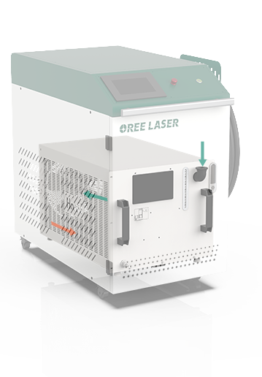

**标配10米焊枪连接光纤**

常规配备10米品质光纤，可实现长距离、大区域灵活焊接，降低作业局限性。

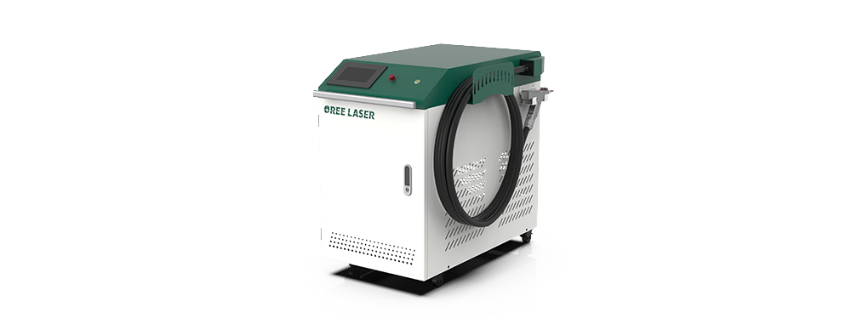

**360度无死角微型焊接**

激光束聚焦光点小，定位精度高，适用于大批量自动化生产的小、微型工件的组焊中，主要针对薄壁材料、精密零件的焊接，可实现点焊、叠焊、拼焊、密封焊等；深宽比高，焊缝宽度小，热影响区小、变形小。

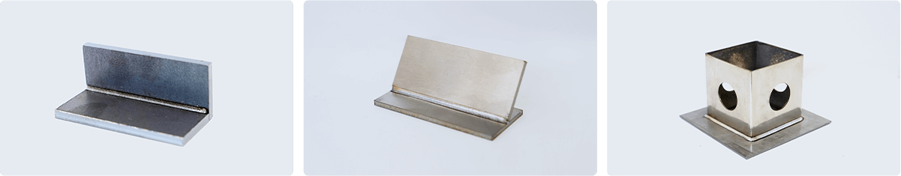

视频中心

技术参数

|  |  |  |  |  |
| --- | --- | --- | --- | --- |
| 型号 | OR-HW-C1000 | OR-HW-C1500 | OR-HW-C2000 | OR-HW-C3000 |
| 功率 | 1000W | 1500W | 2000W | 3000W |
| 激光波长 | 1064±10nm | 1064±10nm | 1064±10nm | 1064±10nm |
| 光纤长度 | 标配10米，长度可定制 | 标配10米，长度可定制 | 标配10米，长度可定制 | 标配10m，长度可定制 |
| 焊接速度 | 2-6000mm/s | 2-6000mm/s | 2-6000mm/s | 2-6000mm/s |

* [Home](https://www.made-in-china.com/)  [Manufacturing & Processing Machinery](https://www.made-in-china.com/products/catlist/listsubcat/132/00/mic/Machinery.html)  [Laser Equipment](https://www.made-in-china.com/Manufacturing-Processing-Machinery-Catalog/Laser-Equipment.html)  [Laser Welding Machine](https://www.made-in-china.com/Manufacturing-Processing-Machinery-Catalog/Laser-Welding-Machine.html)



[Favorites](javascript:void(0);)  Share

# 2024 Wholesale 500W/1000W Laser Automatic Continuous Fiber Laser Welding Machine for Metal/Gold/Silver/Titanium/Nickel/Tin/Copper/Aluminum/Alloy

Reference FOB Price

[Get Latest Price](javascript:;)

|  |  |
| --- | --- |
| **US $2,500.00-12,000.00** / Set | | 1 Set (Min. Order) |
| After-sales Service: | Yes |
| Warranty: | 3 Year |
| Application: | Biomedicine, Electronic Industry, Automotive Industry, Powder Metallurgy, Manufacturing Industry |
| Technical Class: | Continuous Wave Laser |
| Control: | Automatic |
| Power Density: | Deep Fusion Welding |

|  |  |
| --- | --- |
| Samples: | **US$ 1/Piece** 1 Piece(Min.Order)  |[Request Sample](https://www.made-in-china.com/requestSample/prod_AseENDZywFWu_LMOxUhuDAvcB.html) |

|  |  |
| --- | --- |
| Customization: | Available  |[Customized Request](https://purchase.made-in-china.com/send-customized-request/prod/AseENDZywFWu.html) |

## Contact Supplier



Mr. Kevin

[Contact Now](https://www.made-in-china.com/sendInquiry/prod_AseENDZywFWu_LMOxUhuDAvcB.html?plant=en&from=shrom&type=cs&style=3&page=p_detail)

[Leave a message](javascript:void('Please%20Leave%20a%20Message'))

[Inquiry Basket](javascript:add2BasketProd(%200,%20'AseENDZywFWu',%20'//image.made-in-china.com/3f2j00mFVkBDgzwecJ/2024-Wholesale-500W-1000W-Laser-Automatic-Continuous-Fiber-Laser-Welding-Machine-for-Metal-Gold-Silver-Titanium-Nickel-Tin-Copper-Aluminum-Alloy.jpg'))



[**Wuhan Huagong Laser Engineering Co., Ltd.**](https://hgtech-factory.en.made-in-china.com/)

 Diamond Member Since 2019

 Audited Supplier



Manufacturer/Factory

### Product Description

### **Company Info.**

## Basic Info.

Model NO.

LWF500

Laser Classification

Optical Fiber Laser

Type

Portable Welding Machine

Processing Speed

1m/S

Weding Range

70X60mm

Laser Length

1070nm

Power Output

500W/1000W

Power Adjusting Range

5-95%

Transport Package

Wood

Specification

Imported IPG continuous fiber laser

Trademark

HGTECH

Origin

Wuhan, Hubei. China

HS Code

8515809010

Production Capacity

1000sets/Month

## Product Description

**Product Description:**  
  
With the top configuration and international first-class quality, HGLASER continuous fiber laser welding machine has precision welding technology, high performance-price ratio and perfect after-sale service, which wins unanimous praise and gets a good market from all over the world. The continuous fiber laser welding machine is composed of welding mainframe and welding workbench. This series has many workbenches to meet different demands of customers.

|  |  |  |
| --- | --- | --- |
| **Model** | **HW1500** | **HW2000** |
| Laser Source | Imported IPG continuous fiber laser | Imported IPG continuous fiber laser |
| Laser Wavelength | 1070nm±5nm | 1070nm±5nm |
| Laser Mode | Multimode | Multimode |
| Working Mode | Continuous | Continuous |
| Average Output Power | 500W | 1000W |
| Average Consumption Power | 2000W | 4000W |
| Power Adjusting Range | 5-95% | 5-95% |
| Power Instability | ≤2% | ≤2% |
| Transmission Fiber Core Diameter | 50um | 50um |
| Min Light Spot | 0.2mm | 0.2mm |
| Fiber Length | 5m,10m,15m(optional) | 5m,10m,15m(optional) |
| Cooling Method | Water cooling | Water cooling |
| Cooling Water Temperature | 20-25ºC | 20-25ºC |
| Power Supply | AC 220V±10% ,50/60Hz | AC 220V±10% ,50/60Hz |
| Working Temperature | 10~35ºC | 10~35ºC |
| Working Humidity | ≤95% | ≤95% |

1. Good laser beam quality, fast welding speed, stable and beautiful welding joints;  
2. Welding depth-to-width ratio can up to 10:1, smooth and beautiful welding spots, good properties in strength and toughness, without treatment after welding or just with some simple treatment, reduce the labor intensity of workers;  
3. High electro-optic conversion rate, low energy consumption, save a lot of processing costs for customers in long-term use;  
4. High reliability, operated continuously in 24 hours, meet the demands of mass processing and production;  
5. Customize special machines according to customer requirements.  
  
It is suit for gold, silver, titanium, nickel, tin, copper, aluminum and the alloys. It can implement precision between the same metals and dissimilar metals. It has been widely used in aerospace equipments, shipbuilding, instruments, mechanical and electrical products, automobile manufacturing and other industries.  
**Sample:**  
  
  
  
  
**Company Introduction:**  
  
Wuhan Huagong Laser Engineering Co.,Ltd is one of the largest laser equipment manufacturers in China. HGLASER is the main subsidiary company of Huagongtech Co., Ltd. (Stock code: 000988)  
  
HGLASER is a national key high-tech enterprise, possessing technology centers and provincial key laboratories. Relying on the National Engineering Research Center for Laser Processing, National Key Laboratory for Laser Technology and Exhibition Center for Laser Technology Processing, HGLASER undertakes national key projects and scientific research projects.  
  
Wuhan Huagong Laser Engineering Co.,Ltd possesses HGLASER and FARLEY?LASERLAB two famous brands. HGLASER has always been committed to providing broad and comprehensive laser manufacturing solutions in industrial manufacturing field, researching, manufacturing and selling various laser processing and plasma machining equipments, providing tube laser cutting processing and oil pipeline trade services. The main products of HGLASER cover the full power series of laser cutting systems, laser welding systems, laser marking series, laser texturing equipments, laser heat treatment systems, laser drilling machines, laser devices, all kinds of support devices, laser processing and plasma machining equipments, which are used widely in metallurgy, non-ferrous metals, automobiles, parts, aviation, precision instruments, machine manufacturing, hardware, integrated circuits, semiconductor manufacturing, solar, education, communication and measurement, packaging, leathers, plastics, rubbers, jewelries, crafts, medical equipments, etc.  
  
**FAQ:**  
**Q1 :How about warranty?**  
A1:3 years quality guaranty, the machine with main parts(excluding the consumables) shall be changed free of charge(some parts will be maintained) when if any problem during the warranty period.  
  
**Q2: I don't know which one is suitable for me ?**  
A2:Please tell me your   
1) Max work size:We can do work size with 110*100mm-----300mm*300mm.  
2) Materials and marking effect:we will check whether our machine is suitable for you or not and choose a most suitable power and optional parts.  
  
**Q3:Payment terms?**  
A3:TT/West Union/Payple/LC/Cash and so on.  
  
**Q4:Do you have CE document and other documents for customs clearance?**  
A4:Yes,we have Original. At first we will show you and And after shipment we will give you CE/Packing list/Commercial Invoice/Sales contract for customs clearance.  
  
**Q5:I don't know how to use after i receive Or i have problem during use,how to do?**  
A5:  
1) We have detailed user manual with pictures and CD,you can learn step by step.  
2) If have any problem during use,you need our technician to judge.  
The problem elsewhere will be solved by us. We can provide team viewer Whatsapp/Email/Phone/Skype with cam till all of your problems finished. We can also provide Door service if you need.  
  
**Contact Us**  
Wuhan HGLaser Engineering Co.,Ltd.  
Address: HGTECH Laser Industry Park, HUST Science & Technology Park, East Lake High Technology Development Zone, Wuhan  
Zip Code: 430223

